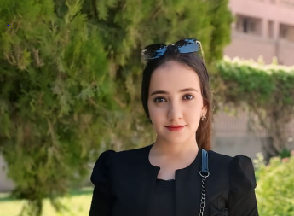
Biography
marina fathy kamel melik

Department of psychiatry and mental health nursing, Faculty of nursing, Assuit University.
Personal Data :
Name : marina fathy kamel melk
Graduation Year : 2022
Study at : Faculty of nursing Assuit University.
Date of birth : 16\9\2000
Phone number : 01276427440
Address : Assuit \ Manfalut
E-mail : marina2000@aun.edu.eg
fathymarina42@gmail.com
# Working as: Demonstrator at psychiatry and mental health nursing ,faculty of nursing , Assuit universit
# Training & courses :
Effective communication skills

The training program on publishing research in international journals

